This artifact is an Android application that allows the user to enter text into a textbox. Once an item is entered, the user can click the Add button at which time that text will create a list and the list will be displayed below the textbox. There is also a clear button which will remove all of the items from the list. This artifact was created at a course taken at Southern New Hampshire University called Mobile Architecture and Programming. I selected this item because I would like to continue creating applications after I’m done with this program at SNHU. I already had a working application and now I’m ready to improve it by adding new functionality which will give the user a new function.

The enhancement I have worked on so far was adding a “Remove Item” button on the same page. Once there is a list populated, the user will be able to enter an item from the list in the text box, and click “Remove Item”. When the button is pushed, the code will check if the text entered by the user matches an existing item in the list. If it matches, it will remove only that item. If there is no text found in the list, a message will appear on the screen letting the user the item was not found.

I was able to get this functionality working as expected. I also updated the code after looking at my code review comments. I did this by ensuring all variables were appropriate, updated code formatting, as well as checking any new operands and ensuring those are sufficient. Through enhancing this project, I learned a lot and also had to jog my memory on the setup for this project since it has been awhile since I’ve last touched it. At first, I needed help getting started and after finding a couple of resources online of related functionality, I found that the Add button didn’t have an on click listener and had to find a different way to implement this. I was able to do this by creating the removeButtonClick method without an on click listener. I also had to create a method in the ToDoList class that will return a Boolean if the text entered matched the existing list. I then looked at the Add button and used some similar concepts from that method which worked. Another challenge I came across was solving errors. I solved most of them so far with the help of online tutors getting the right Java language.

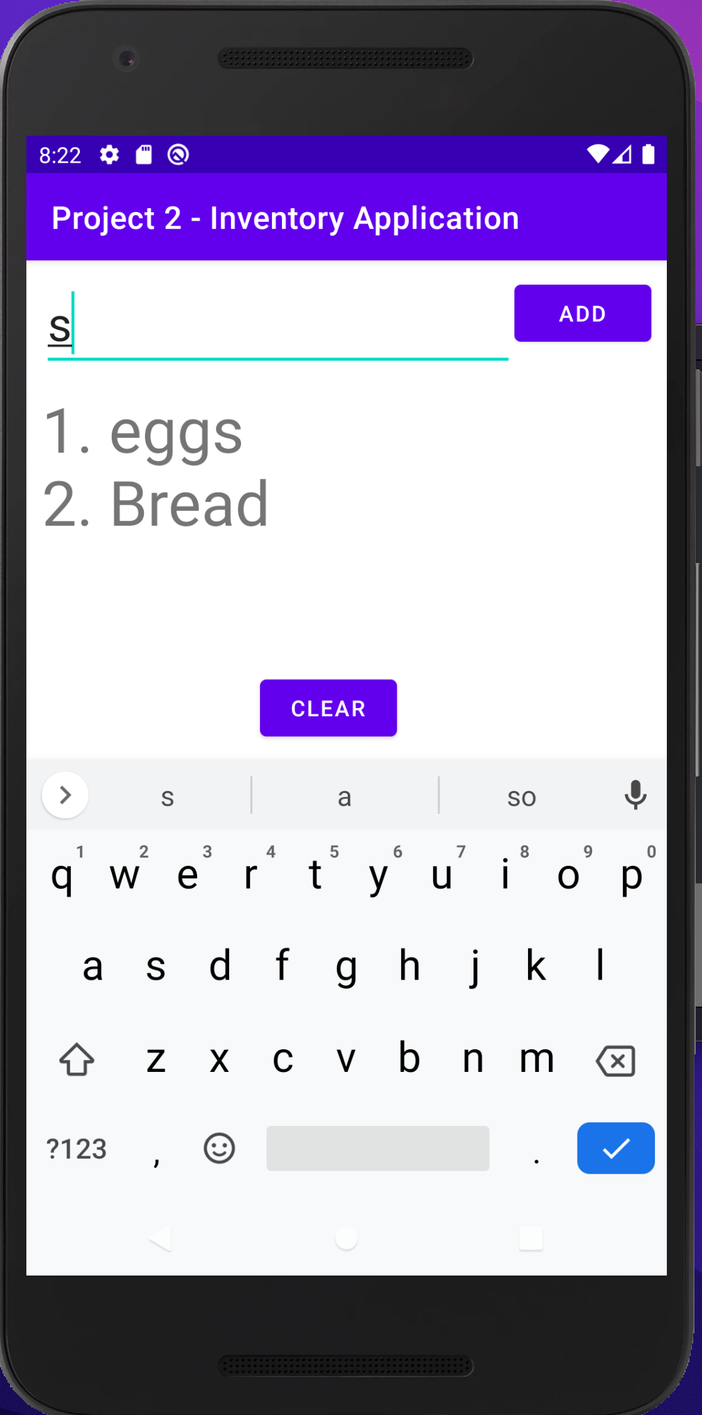

Figure A -Prior to the Enhancement



Figure B - Remove Item button added

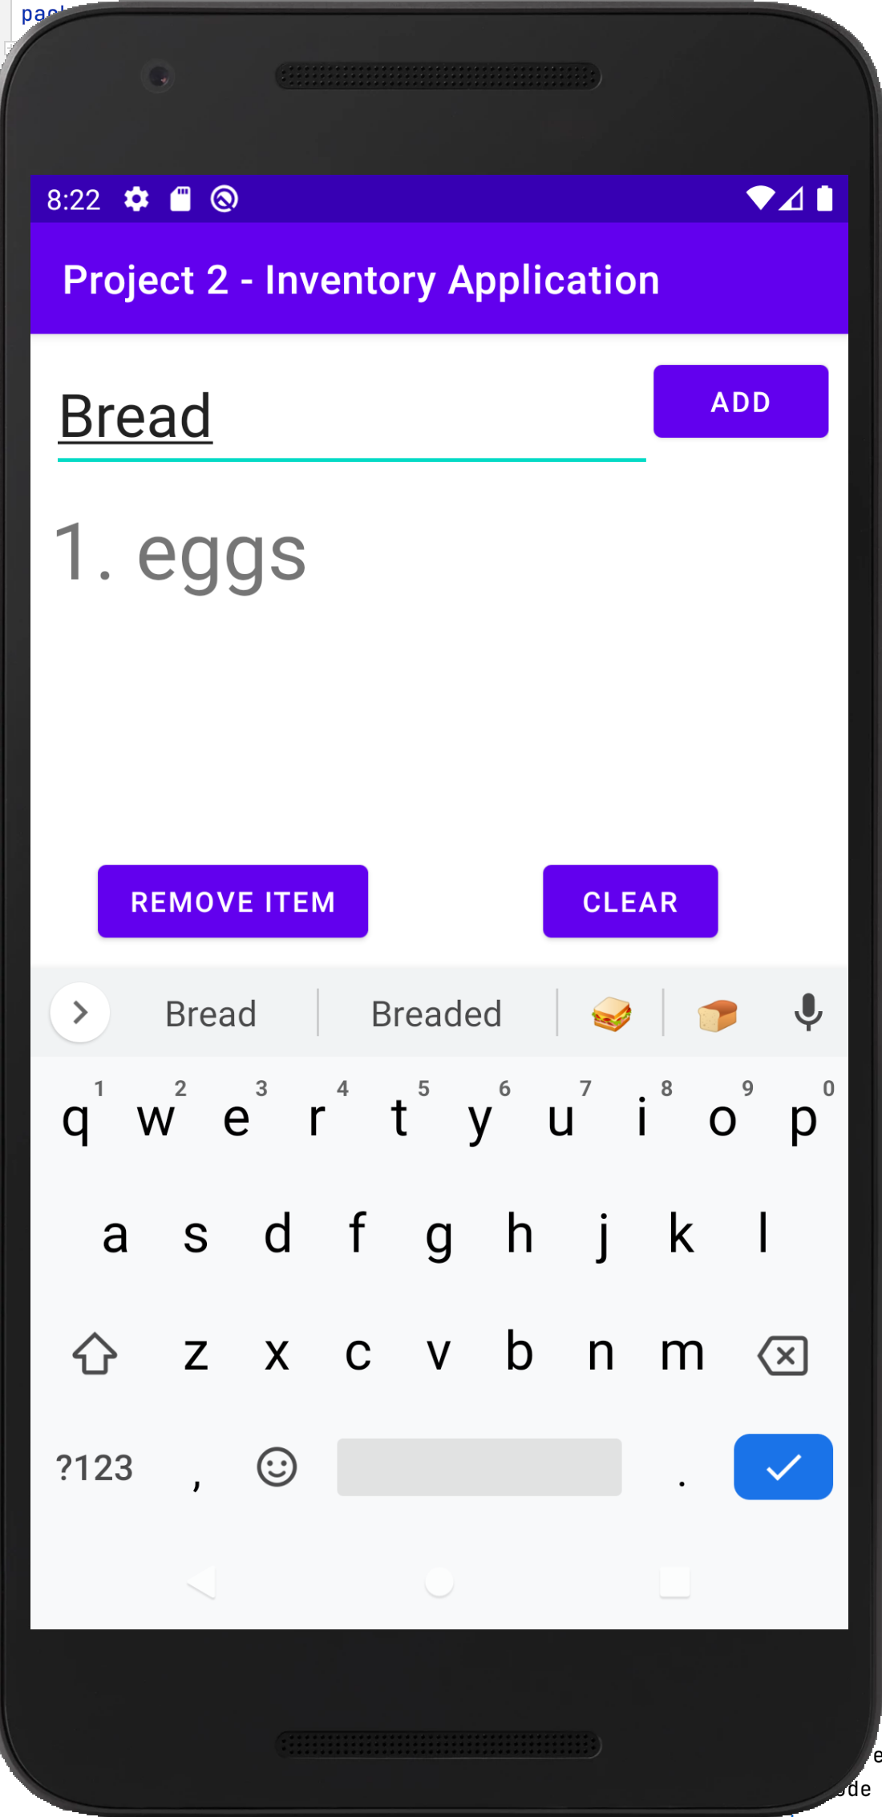

Figure C - Updated list after entering “Bread” and clicking Remove Item button.